Booking a Flu Vaccine Appointment – Guide for Patients

The following is a guide on how to book a flu vaccine appointment if you have received an SMS invite to do so. If you have not received an SMS invite, then it may be that we do not have a mobile phone number for you, or you have informed us that you do not want to receive SMS messages from the Partnership.

The following screenshots are for illustrative purposes only. Content may differ slightly.

1. You will receive an SMS message with two links. One link will be to these instructions, the other will be the link to book your appointment.

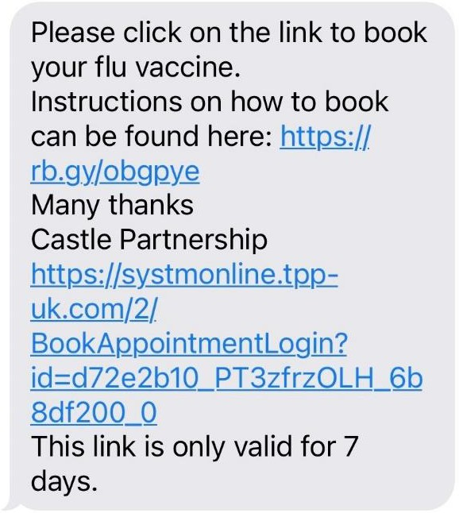

1. To book your appointment, click onto the longer link.
2. This will open the front page of the Appointment Invitation Service booking system.

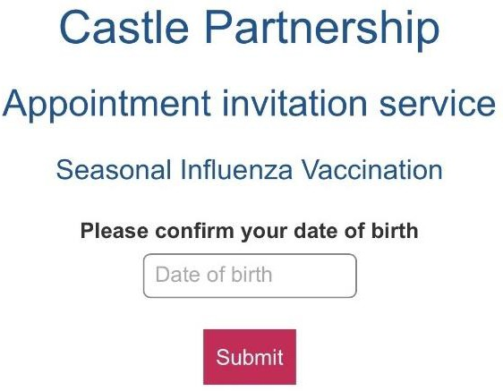

1. You will need to confirm your date of birth. Type this into the box in the following format: **DD/MM/YYYY** & click the ***Submit*** button.

When you click into the box, it will automatically bring up a small calendar if you would rather use this.

1. This will then take you to a new page showing you available sessions. Depending on the date there may be no sessions shown, as is the case in the screenshot below.

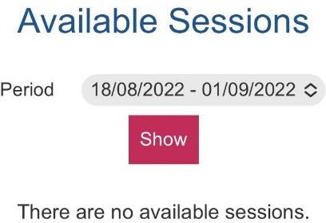

1. If there are no sessions shown, then click on the ***Period*** and a range of other dates will drop down.
2. Select the date range and then click the ***Show*** button.

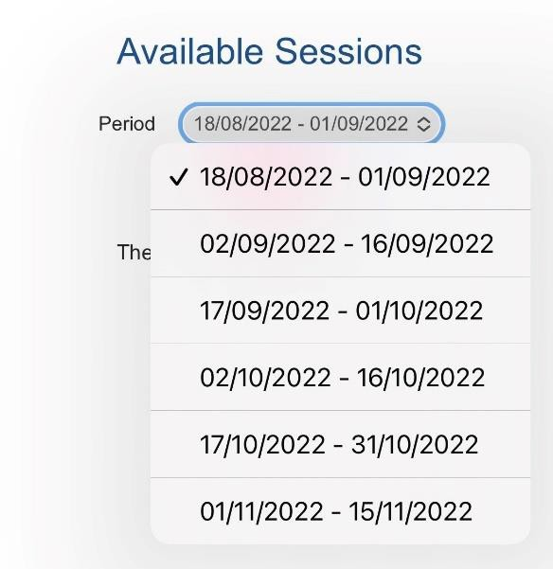

1. This will then show you the flu clinics that you can book into.

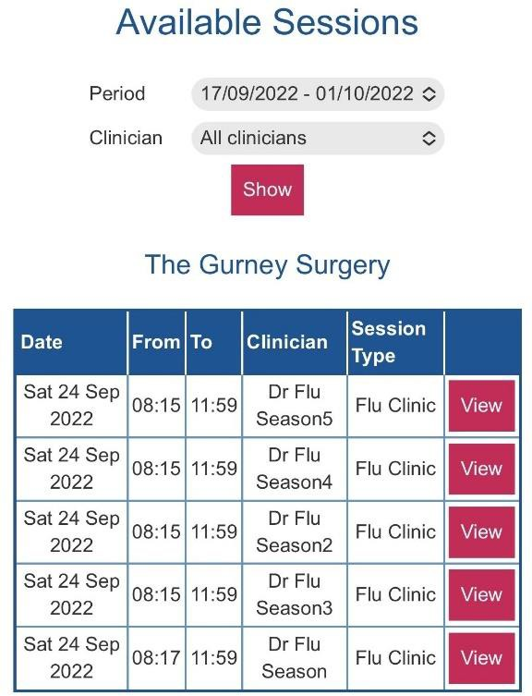

1. Click the ***View*** button. This will open a new page showing you what times are available for you to book an appointment.
2. To book the time you would like, click the ***Book*** button. Flu appointments are 2mins.

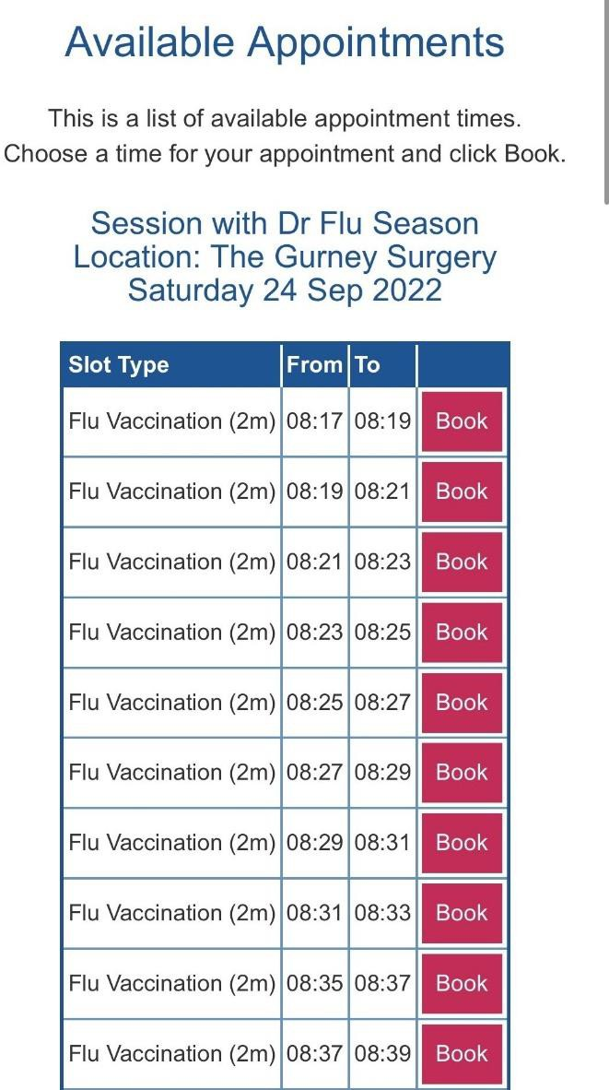

1. This will then provide you with a screen to check if you are happy with the location and the time of the appointment you are looking to book (*Please note that if you are using a mobile device, you may have to scroll across to see all the details).*
2. If you are happy with the date, time and location, then click ***Book Appointment***. If you want to change the appointment, then click ***Cancel****.*

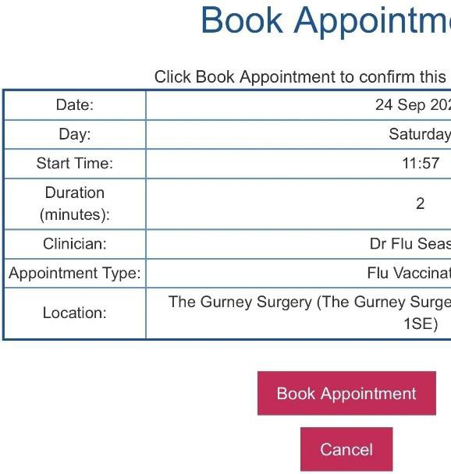

1. Once you have pressed the ***Book Appointment*** button, you will see an Appointment Booking Confirmed screen advising you of the details. Please make a note of the date, time and location of the appointment. If you are set up to receive appointment reminders a reminder SMS will be sent to you a few days before your appointment is due.

