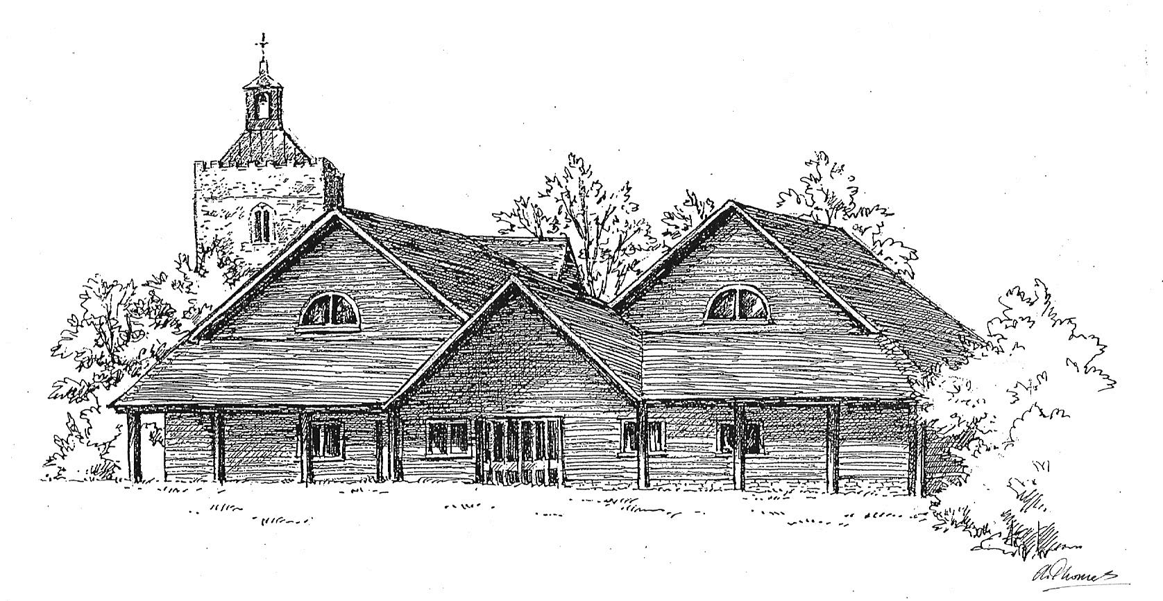
Freshwell Health Centre
Patient Satisfaction Questionnaire Results 2013-14
Our questionnaire for this year, as in the previous two years, was designed using feedback and ideas from our Patient Reference Group. Some of the questions (areas in which changes had been made following last years’ results) were repeated and some new areas were added.

Patients Responding to the Questionnaire.
Questionnaires were distributed in February 2014. We received a total of 250 completed questionnaires from patients. The graphs below compare the demographics of the response cohort and the practice population.

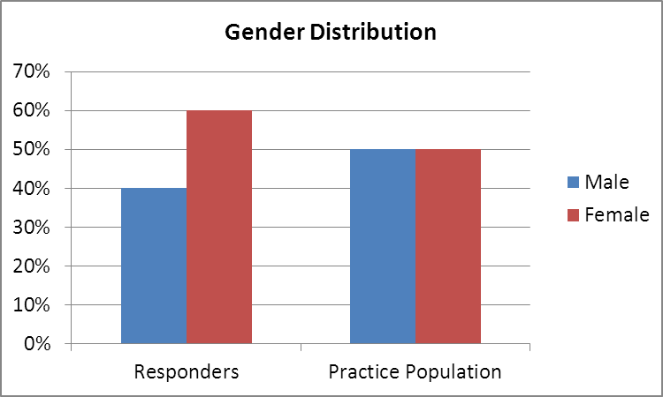
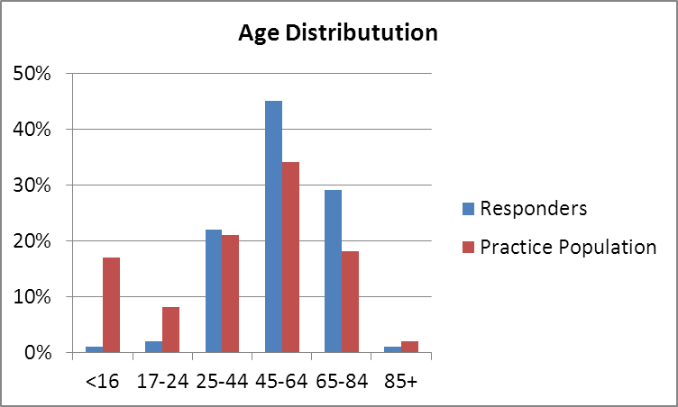

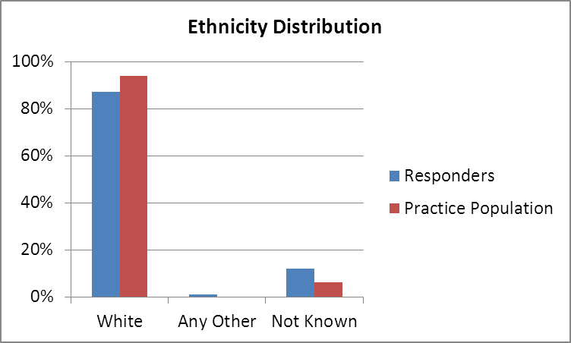

Of the 225 patients responding to the question on how often they visited, 32 said rarely, 107 said occasionally, 76 regularly and 10 often.

Comments on these findings:
We would not expect the responders to mirror the practice population for various reasons including
- children would not be expected to complete the questionnaires
- the elderly tend to have more health problems than the young
- not all patients with appointments completed questionnaires
- elderly patients may have fewer constraints on their time.
The ethnicity distribution of responders matches that of the practice closely.
This information shows that a cross section of patients have completed the questionnaires.

Booking Appointments: Patients were asked to comment on booking this / their last appointment at the practice.

 | Number of Responses | Strongly Agree | Agree | Neither Agree nor Disagree | Disagree | Strongly Disagree | % of Patients who strongly agree or agree
It was easy to get through on the phone | 230 | 124 | 92 | 7 | 7 | 0 | 94%
I was offered a choice of clinicians | 203 | 62 | 62 | 53 | 21 | 5 | 61%
The appointment I booked was at a convenient time for me | 235 | 144 | 79 | 9 | 3 | 0 | 95%

Patient comments about booking appointments, requesting home visits or our opening hours:
Long wait to see specific doctor.
Easy to book and nearly always get a convenient day and time.
Always good.
I like that appointments can be booked in advance however was unable to get an appointment quickly when I needed one.
Have always been able to make an appointment on either same or next day.
I find the current system very fair.
The receptionists don't need to know the nature of the appointment, it should be confidential.
I would like to say how great I think this practice is. All staff are always helpful. Always seen on day if urgent or within a day which means a lot. Front desk will always help you out with any problems. Nurses are great too. As you can see I think a lot of this practice.
Reception always helpful.
I usually book appointments on line without a problem
Very easy to make appointments at a convenient date / time.
Booked on-line, very easy. I think booking on-line is wonderful, I am so glad we as patients don't have to ring the same day as some practices insist on - I gather this results in an unholy scramble every morning.
Choice of clinician wasn't needed. We were happy to be seen at such short notice. As always, from mine and my friend’s point of view, everyone is always so helpful and friendly.
Sometimes difficult to get through.
I actually make my appointments mainly using on-line which is efficient. I only wish you could book blood tests the same way.
I did not know about the times the surgery closes. Perhaps this could be displayed more prominently.
Always very helpful and accommodating.
Well run, well organised.
Appointment with nurse for annual review (no choice available).
Booked appointment via doctor so no phone call or choice required.
Generally delighted with service. More 'out of office' hours appointments might help those with work and travel commitments.
Have never asked for above (urgent appointment)
Very helpful, do not have to wait for appointments and telephone advice is very useful.
Excellent always.
Made appointment in person.
I have never had to wait long to be seen.
Excellent!
Not urgent but seen on same day
Always helpful and friendly on the phone.
It would be great if the older patients could be seen between the hours of 9.30 and 3.00 to free up mornings for kids of school age, working parents and workers generally.
Always manage to accommodate needs.
Would like to have after work same day appointments as urgent booking, say 5-6 pm.
This practice is most accommodating with appointment times - so helpful when you have to work and children are at school.
I feel that it is always easy to get an appointment, this is a great service, especially with children.
I use the online service which I find extremely helpful
No spaces left in the car park
We prefer to see a chosen clinician.
I was seen without an appointment. No bother.
Booked on line. Very convenient, non-urgent.
If you can't get an appointment on the same day a doctor will call you back - excellent service!
Generally very good.
I took the appointment offered me.
Always helpful and friendly.
They fit you in for urgent appointments on the day.
Later opening in the evenings and also Saturdays for routine appointments.
Fantastic, couldn't ask for more.
Booked on line.
I didn't need an appointment on the same day but when I have required this I have always managed to get one.
Not offered choice of clinician on last visit.
I usually book on line.
Booking appointments and requesting a home visit have always been available when needed. Opening hours suit me.
Excellent.
I booked my appointment on line. Very straight forward, no hassle at all.
The appointment I booked was at a convenient time for me but I wanted to see a doctor on the Thursday and the appointment I got was on the Monday.
Never any problems getting appointments!
Always very good.

Comments on these findings:
This was a new area added to the questionnaire this year so no comparable results from last year are available. The results for getting through easily on the telephone and appointments being at a convenient time are encouraging.
Of those 26 patients that either disagreed or strongly disagreed that they were offered a choice of clinician 7 (27%) had booked an urgent appointment, 14 (54%) had booked a routine appointment and 5 (19%) did not state which type of appointment they had booked. Although it is not always possible to offer a choice of appointments for emergency appointments, this is something we can offer for routine appointments and a simple change in the phrasing used by the receptionists should remedy this.
There are several comments relating to booking our early morning or later evening appointments. Whilst we would never discriminate against any group of patients we could review the use of these appointments to ensure we are making them available in the most appropriate way.

On Arriving at the Surgery: Patients were asked to comment on this / their last visit to the practice.

 |  | Number of Responses | Strongly Agree | Agree | Neither Agree nor Disagree | Disagree | Strongly Disagree | % of Patients who strongly agree or agree | 2012-13 Result
The reception staff: | were friendly | 247 | 189 | 57 | 1 | 0 | 0 | 100% | 99%
The reception staff: | listened to my concerns | 197 | 98 | 61 | 37 | 1 | 0 | 81% | 92%
The reception staff: | were helpful and informative (eg about delays to appointments) | 210 | 105 | 68 | 36 | 1 | 0 | 82% | 97%
The reception staff: | were efficient | 241 | 164 | 73 | 4 | 0 | 0 | 98% | 100%
The reception staff: | were professional | 235 | 166 | 68 | 1 | 0 | 0 | 100% | 99%

Patient comments about reception staff:
Lovely friendly receptionist - always a pleasure to come in.
Always have time to listen to problems and suggest solutions.
Always good.
Calm atmosphere
Always very pleasant.
Very helpful indeed
I always find Anne particularly helpful.
As I have said above they (reception staff) are great. They are always helpful be it for appointments, letters or just helping with some advice. I always feel able to approach them with any reason so a big thank you to them.
Overall very pleased.
Couldn't ask for more. We're so lucky to have a fantastic and professional service on our doorstep.
Great staff.
No info regards delays if applicable.
You have one brilliant lady on reception who is so lovely I only like talking to her. The rest should take note. She has glasses.
Staff at Freshwell have always been brilliant from the reception staff, nurses and doctors.
Very good.
Very helpful and friendly.
Always very helpful.
Very friendly.
I wasn't offered the information about the doctor running late, I had to ask.
They are always willing to help and always with a smile. Very rare anywhere else.
Have always found them helpful and pleasant.
Excellent!
Always very happy to help and accommodate where possible.
Staff always friendly
Very impressed with the staff.
Always helpful, professional and friendly.
The ladies are always helpful and polite.
Always helpful.
Always helpful and accommodating.
We are so lucky to have such a wonderful surgery.
I came in recently quite distressed regarding a prescription for my wife who has cancer. The prescription was for the hospital pharmacy and I did not realise this. They went to an available doctor to get the prescription changed so that I could get the tablets. What else can I say 100/100.
They are extremely busy handling calls and the computer. Only 2.
They are all the best.
Always very helpful.
Always pleasant.
Always friendly even when under pressure.
They are superb.
Always friendly!
Very good always.
I have found the reception staff really welcoming which makes a great difference to older patients.
They are all very helpful.
Always helpful.
Always helpful and try to fit you in for an appointment.
Example (of receptionist being helpful): I habitually ask the receptionists to lend me a pencil to record appointment and they always oblige with a smile.
It's always nice to have a welcoming smile.
Receptionists are always polite and helpful
Always very polite and friendly.
Excellent reception, nurses etc.
Always very considerate to me and helpful.
Always very helpful and friendly.
Always very helpful and accommodating.
When nurse was called out on an emergency on one of my appointments I was left for nearly an hour with no-one coming to let me and other patients know. We had to go to the desk.

Comments on these findings:
The overall results in this section are very encouraging and demonstrate the dedication and hard work of our reception team. There are some lovely comments. I am sure the receptionists will reflect on the drop in results for ‘listening’ and being ‘helpful and informative’. If a doctor is running late this information is now displayed on our screen which may indicate why the receptionists have not been telling as many patients about delays.

The Waiting Room: Patients were asked to complete the questions for this / their last visit.

 | Number of Responses | Strongly Agree | Agree | Neither Agree nor Disagree | Disagree | Strongly Disagree | % of Patients who strongly agree or agree
A wide range of health promotion information was displayed | 229 | 120 | 99 | 10 | 0 | 0 | 96%
Useful information about the surgery was provided (including updates about any delays to appointments) | 217 | 84 | 88 | 40 | 5 | 0 | 79%

Patient comments about the waiting room facilities:
Clean.
Could do with water dispenser and a fan or ventilation.
Screen is a good addition
The new chairs in the waiting room mean that anyone 5'3'' or under can't put their feet on the ground. This adds to physical tension and poor posture at what is a stressful time.
Great to see the TV screen with info.
The addition of the plasma screen is very welcomed.
The TV screen is very good.
I think it's a lovely waiting room, well-kept and very clean.
Love the TV screen.
A very comfortable waiting room with mags.
Very pleasant place to have to wait.
Always neat and tidy
Always a pleasant place to wait and having the bookshelves is brilliant and I often end up coming away with a couple.
Some out of date literature still on display.
Clean, warm and comfortable.
Always clean and tidy and plenty of comfortable chairs.

Comments on these findings:
This was a new area added to the questionnaire this year so no comparable results from last year are available. In the 2012-13 survey we received a lot of comments about there not being enough facilities and information available in the waiting room and making improvements in this area was part of last year’s action plan. Over the last year we have introduced an electronic information screen, new chairs (there are now 5 styles to choose from) and a suggestion box. Despite several patient requests in the survey last year and the suggestion box we will not be providing drinks facilities as to do so has health and safety implications and we would rather focus our efforts on our core services i.e. healthcare. Any patients needing a drink of water can ask for one at reception. The results in this year’s survey are better for the health promotion information than for the surgery information which indicates that we can make further improvements by adjusting the type of information displayed on the screen.

Clinical Care: Patients were asked to complete the questions for the doctor or nurse they saw at this / their last appointment. Of the 232 patients answering this section, 165 had seen a doctor and 67 had seen a nurse. Some patients did not indicate the type of appointment and some had seen both types of clinician. (Note: The figures from 2012-13 are not an exact comparison as last year we only asked about appointments with the doctor and did not include nurse appointments.)

 | Number of Responses | Strongly Agree | Agree | Neither Agree nor Disagree | Disagree | Strongly Disagree | % of Patients who strongly agree or agree | 2012-13 Result
After arriving at the surgery, the wait to see the doctor or nurse was reasonable | 226 | 81 | 107 | 27 | 9 | 2 | 83% | 86%
I was happy with the medical care I received | 224 | 129 | 90 | 4 | 1 | 0 | 98% | 97%
The doctor or nurse listened to my concerns | 225 | 140 | 83 | 1 | 1 | 0 | 99% | 98%
Adequate time was given to my problem | 220 | 123 | 93 | 2 | 2 | 0 | 98% | 95%
I received clear explanations or written information about my problem | 222 | 129 | 83 | 9 | 1 | 0 | 95% | 92%

Of the 9 patients who disagreed that the wait was reasonable, 6 saw a doctor and 3 saw a nurse, 1 had booked an urgent appointment, 5 a routine appointment and 3 had not answered that question.
Of the 2 patients who strongly disagreed that the wait was reasonable 1 saw a doctor and 1 saw a nurse, 1 had booked an urgent appointment and 1 a routine appointment.

Patient comments about consultations or clinical care:
Dr Andrews has been caring for me very well and because she is having a baby kindly recommended a doctor to take over my care whilst she is away.
I was in a consultation with my son and the doctor’s phone rang. He did ask if it was ok to answer and we agreed but he was on the phone to another patient for at least 5 mins which I thought was a bit rude. We could hear most of the conversation about sectioning someone.
Happy with service.
Very good throughout
It is always first rate.
All the nurses are great, always very helpful and never rush you. Today I went with an additional query on medication and it was sorted in minutes. Thank you.
No wait at all. A gin and tonic would have been nice!
I can't praise the staff any more. They are always convivial and informative and rounded in their approach.
Dr Walker very clear in explaining anything.
Based on my previous visit as sheet filled in whilst waiting.
Had a good discussion (about lifestyle).
35 minute wait (to see doctor). The doctor today was sympathetic and understanding.
Reluctance to refer me even though I had private insurance - need an operation but have had issues since last April.
I had blood tests on my previous appointment and never received the results.
Always helpful and thorough.
Always helpful and very professional.
Waiting times are abysmal. Up to 30-40 minutes which is unprofessional and time wasting.
Nurses very attentive. Doctors always busy!
No problems, always feels personal.
Very accommodating doctor.
Not seen a doctor yet, no offence, but fingers crossed!
Mary Joy was spot on as usual!
Mary Joy was very helpful.
I have been very pleased with my doctor's caring attitude, she listens.
Doctor was called away on an emergency so had to wait nearly 45 minutes - but was kept informed and offered another appointment.
25 minutes (wait to see doctor)
Always very caring and helpful.
I understand 'higher authority' specifies that appointments are for max. 8 minutes. I doubt this is realistic and probably accounts for delays.
Friendly and professional.
I have complete confidence in the doctor who I always see, and the nurses.
15-20 minutes wait from appointment time

Comments on these findings:
These results are excellent in all areas except for the wait to see the doctor or nurse where there is still room for improvement. The overall satisfaction had gone down slightly although less patients than last year ‘strongly disagreed’ that the wait was acceptable. Clearly, we have not solved this problem yet.
Unfortunately, emergencies and patients that need extra time cannot be planned. These situations cause major disruption to running times and are out of our control. We are considering other options such as providing an emergency duty doctor but this would have a knock on effect in terms of the availability of that doctor to see their patients for routine appointments.

Lifestyle Advice: Patients were asked if they would have liked to be given more lifestyle advice when seeing the clinician. This question was deliberately negatively phrased so that the ‘best’ answer was ‘strongly disagree’ rather than ‘strongly agree’. This is a device used by questionnaire designers to see how carefully the questions are being read. Both this year and last year a number of patients had ticked the same column all the way down the section possibly showing that not everyone reads all the questions carefully! The results for the two years are below.

When last seeing a nurse or doctor I would have liked to be given more lifestyle advice | Number of Responses | Strongly Agree | Agree | Neither Agree nor Disagree | Disagree | Strongly Disagree | % of patents who disagree or strongly disagree
2012-13 results | 217 | 11 | 41 | 112 | 43 | 10 | 24%
2013-14 results | 195 | 20 | 33 | 90 | 36 | 16 | 27%

Comments on these findings:
Over the last year, as stated in last year’s action plan, we have increased the health promotion information provided in the waiting room and doctors and nurses have reflected on the written information they provide for patients. Although the results for this negatively phrased question are not as reliable as for the other questions, there is an improvement in this area.

Collecting Medication: Patients were asked to give their opinions on collecting medication on this occasion.

 |  | Number of Responses | Strongly Agree | Agree | Neither Agree nor Disagree | Disagree | Strongly Disagree | % of Patients who strongly agree or agree | 2012-13 Result
The dispensary staff: | were friendly | 169 | 73 | 79 | 12 | 5 | 0 | 90% | 94%
The dispensary staff: | listened to my concerns | 139 | 45 | 48 | 43 | 3 | 0 | 67% | 86%
The dispensary staff: | were helpful and informative | 150 | 58 | 55 | 32 | 5 | 0 | 75% | 89%
The dispensary staff: | were efficient | 162 | 65 | 71 | 19 | 6 | 1 | 84% | 95%
The dispensary staff: | were professional | 156 | 70 | 67 | 17 | 2 | 0 | 88% | 96%
The wait to collect medication was acceptable |  | 152 | 46 | 75 | 19 | 12 | 0 | 80% | N/A

Patient comments about the dispensary:
Too many products not reordered. Most visits you hear staff say they have no stock. If not source elsewhere. Room too small for purpose. Very old fashioned. Boxes on floor not safe.
Sometimes given wrong medication.
My experience with the staff in pharmacy has always been great. I have many different reasons to deal with them and on every level they are always helpful. Thank you.
Have to collect medication elsewhere as live less than a mile from a pharmacy. Be better to collect here after seeing a doctor.
Seem very pressured on occasions.
Really am fed up with the constant change in brand of my medication.
Wait to collect medication not always acceptable.
Not much in the way of privacy. Staff often seem loathed to serve you. Medication often not in stock.
They are helpful and pleasant even in times when one can sense tension.
Generally a good service. It is a shame that you cannot get more than 1 month's prescription at a time.
Cheer up please staff in dispensary. Chat to customers a little more and smile!!
Very good.
There have been problems with missing items in the past but, reading the newsletter, looks like this is set to improve.
Always smiling, even under duress with work.
At times the wait has been long but this has been better of late.
I have been coming to this doctors my whole life - 37 years. My family still live in Finchingfield but I now live in Rayne and have to collect my prescriptions elsewhere which is extremely annoying and inconvenient!
Regular prescription ordered and unfortunately the main medication will often be missing although plenty of time given.
Overall a good service.
Not always easy to order a repeat prescription over the phone, wrong time of day. On-line works very well.
The service here is very good.
More privacy please.
Wait for meds took a while.
No discussion required.
This is my principle contact with Freshwell - collecting repeats I order by email and this works well.
There seems to be delays in getting repeat prescriptions. Frequently longer than the stated 2 day period.
It is so convenient to have the dispensary in the same building.
Some dispensary staff are very helpful (ie Louise) some less so.

Comments on these findings:
We have been aware of problems within this department over recent months and a lot of changes (including additional staff and amended procedures) have been introduced already. Although these changes will take a while to take effect, it is clear that we are still not getting everything right in this department and these results are disappointing. There is nothing we can do about dispensing to patients who live near a pharmacy, sourcing the more cost effective brand of medication to help make the most of NHS resources or collecting prescriptions monthly as these are nationally determined. We can, however, make improvements to the facilities and patient privacy, make sure staff work in a safe way, minimise errors, reduce waiting times, improve staff attitudes and have good stock control. We have more work to do in this department and we are listening.

Out of Hours Service: Patients who had used the new NHS111 service in the last 3 months to obtain out of hours care or advice were asked to complete this section.

 | Number of Responses | Strongly Agree | Agree | Neither Agree nor Disagree | Disagree | Strongly Disagree | % of patients who strongly agree or agree
The staff were friendly and helpful | 32 | 8 | 11 | 13 | 0 | 0 | 59%
The call was answered efficiently | 31 | 8 | 10 | 12 | 1 | 0 | 58%
I was happy with the clinical care I received | 30 | 8 | 9 | 13 | 0 | 0 | 57%

Patient comments about the out of hours service:
I wouldn't use NHS111 as a lot of the time they are staffed by admin staff.
I wish there was a community programme (there may well be which I am not aware of which embraces the problems of rural living and getting old. I'm surrounded by people who are in their late 80s or 90s and some are house bound. I would like to see some form of community doctors / nurses that would call regularly on these people. I think they were called health visitors years ago. I know it puts great strain on your resources but being a fantastic rural surgery I feel it is not beyond your enterprise to come up with something which could be advertised in parish mags etc. Finchingfield is such a fantastic facility and a jewel in the crown of health provision and should be an exemplar to other surgeries in our vast county.
Bring back our doctors on after hours call outs.
I thankfully haven’t had to use this service of late but when I did was treated well
Was better before 111 service.
Haven't used this service for 3-4 years. Very good however ambulance wait was 9 hours.

Comments on these findings:
This was a new area added to the questionnaire this year following concerns expressed by some of the Patient Reference Group about the new NHS111 service introduced in 2013. We will pass these results on to the Mid Essex Clinical Commissioning Group who commission this service for our area. Although the numbers of patients responding is low, the satisfaction levels are a long way below those of the services we run ourselves within the surgery.

Additional General Comments by Patients

Positive Comments made by Patients
This is the best doctors' practice I have attended. I feel very privileged.
Very happy with care received to date.
Very helpful surgery all round.
Very good job carried out
Freshwell is a great practice. Much better run regarding appointments than a lot of others. I hope it never changes. All staff from doctors to secretarial have always been helpful and give me confidence which is very important to me.
An excellent facility
On the whole the doctors, staff and general service is absolutely excellent!
I like this surgery, always very helpful.
We are very lucky to have such great facilities and if extra money or equipment was necessary we should ask patients to fundraise more.
I always have a good experience.
So lucky to have such a lovely surgery.
Exceptional service.
We are very lucky to have this surgery, it's the best one for miles around.
Excellent surgery
A very efficient and friendly surgery.
I am and always have been pleased with the staff and the practice. The range of facilities is excellent.
I have always found the staff, whether medical or support, to be very friendly and helpful, It is a pleasure to come to this surgery!
Very well looked after.
Excellent staff and facilities.
I feel the services offered at Freshwell are excellent.
Rachel, the lady who takes my blood gets it first time every time. At St Michael's Hospital they used to try 3 or 4 times. Thank you, Rachel.
Always very impressed by how helpful everyone is and always manage to get an appointment pretty soon.
Wouldn't want to be registered anywhere else.
Best surgery in the area.
Excellent surgery.
Generally very pleased.
On the whole I have found the services good.
We are fortunate to have Freshfields Clinic.
Best and happiest surgery going.
Excellent service.
Excellent surgery. We are lucky to have it.
We are extremely lucky to have such a brilliant service in this area. I can't fault this GP practice and any referral to hospital services have always been achieved very quickly. All the staff at Freshwell are professional and effective and any fundraising work could be more widely publicised.
Moving to Freshwell was the best move I could ever have made.
Both my wife and myself have the utmost respect for all the staff. Over the years we have attended we have always been very satisfied with the treatment and care received. (name supplied)
Well done in all departments!
I consider myself lucky to live in the catchment area of this clinic.
I appreciate Freshwell Health Centre very much, I feel lucky to have such a good practice.
I consider myself very lucky to be a patient at the Freshwell Health Centre with all its extra amenities on site and an excellent team of doctors and nurses.

Negative Comments made by Patients
Difficult to get an appointment with the doctor of your choice - can take a week!
Waiting times sometimes longer than expected.

Other / Mixed Comments made by Patients
All the doctors and nurses I have seen have been extremely good. Do feel attitude of some dispensary staff let the surgery down.
(My) only concern was mentioned in the dispensary comments.

Overall Conclusions
We are very grateful to the Patient Reference Group for their help in designing this questionnaire. On the whole, these are a very pleasing set of results. Positive comments provide useful feedback about the strengths of an organisation and help to demonstrate to staff that their efforts are noticed by the customers. Negative comments allow for reflection of where weaknesses may be. Some of the negative comments relate to situations beyond the control of the practice (Non-dispensing addresses) but others give an indication of where improvements can be made.

Areas for Further Reflection and Action Plan

Topic | Actions | Timeframe and Lead
Staff Training | To  - undertake further customer service training for staff, concentrating on those working in the dispensary  - encourage reception staff to offer more choice of clinician and to continue to inform patients on arrival if the doctor is running late | July 2014  (L Cutts & D Oliver)  April 2014  (L Cutts)
Waiting Facilities | To adjust the balance between health promotional and practice information provided in the waiting room by adding more specific information about the practice. | May 2014  (L Cutts)
The Wait to See the Doctor | To review the appointment schedules and reasons why delays occur. To make adjustments to the appointment system based on the findings of the review. | June 2014  (L Cutts & Partners)
Evening Appointments | To review the use of evening appointments and find ways of making these available to those who are unable to attend at other times of the day. | August 2014  (L Cutts & Partners)
Dispensary Facilities | To review the design, layout and working practices within the dispensary to try to  - afford greater privacy for patients  - improve customer service and reduce waiting times  - reduce errors  - improve storage capacity and hence stock levels. | October 2014  (D Oliver)
Out of Hours Cover | To pass on these findings to the commissioners of the Out of Hours Services. | April 2014  (L Cutts)

Linda Cutts, Practice Manager

