**PARKSIDE SURGERY**

Salaried GP Advert

(5-8 Sessions)

Based in Alfreton, Derbyshire

**Salary – dependant on experience**

**Why work at Parkside?**

* PMS practice with modern premises.
* Paper light Systmone practice with integrated Ardens Templates and use of Accurx.
* Supportive GP practice with all partners being GP trainers and we have a "open door" policy.
* Well regarded training practice, currently with registrars from Derby and Chesterfield. We are a large training practice which means minimal visits and lots of educational opportunities.
* Very supportive management and a skilled admin team which includes prescription clerks, document management and secretarial support for referrals resulting in minimal paperwork.
* Weekly practice meeting with fellow colleagues. Weekly educational meetings to help keep knowledge up to date.
* Work closely with ARCH PCN – access to clinical pharmacists, pharmacy technicians, First contact physio.
* Access to the ARCH acute home visiting service – this and being a large training practice means visits are currently minimal for GPs at our surgery.
* We place a high importance on the wellbeing of our staff - we have regular check in sessions and last year we had Afternoon Tea, a Christmas Party and a Christmas Fuddle.

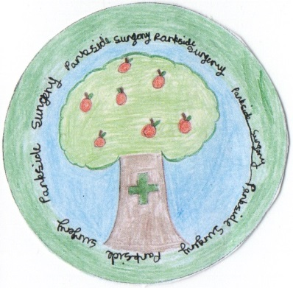

***We are looking for an enthusiastic, innovative, and highly motivated GP to join our friendly team. We currently have 5 partners and 4 salaried GPs. Our list size is 10,700 patients and steadily increasing.***

**Why Alfreton?**

* Surgery is next door to a leisure centre which hosts a swimming pool and a gym.
* Close to Alfreton Hall and Alfreton Park which provide beautiful walks and countryside.
* Next to Alfreton high street which has many shops including a Costa and a large Tesco.
* Good transport links, close to M1,close to the Peak District.

***Informal visits are encouraged and welcomed by the practice. To arrange, please contact Cheryl Annable, Practice Manager on 01773 546933 or*** [**cheryl.annable@nhs.net**](mailto:cheryl.annable@nhs.net)

***For a clinical discussion, please contact Dr Nic Hall by email*** [***nicholas.hall1@nhs.net***](mailto:nicholas.hall1@nhs.net)

Our website:

[www.parksidesurgery.co.uk](http://www.parksidesurgery.co.uk)

Address: Primary Care Centre,

Church St, Alfreton DE55 7AH