PATIENT INFORMATION LEAFLET –
GENERAL DATA PROTECTION REGULATIONS
Under the General Data Protection Regulations, from 25th May 2018 patients have the right to apply to see, or have a copy, of their health records. When this regulation is introduced there will be no charge for these requests except in specific circumstances, such as if the requests are manifestly unfounded, excessive or numerous.

To inform the patients of what GDPR means, we have prepared these information leaflets to help patients to understand;
- What is GDPR
- What ‘patient data’ means
- What ‘consent’ means and why they will be asked for it.
There are two version of the leaflet;
- Version A – A4 leaflet (front & back)
- Version B – A5 leaflet (front & back)

These should be printed double-sided – for any version of MS Word after Windows 2003, you can use the following steps;
- Go to ‘File’ and choose ‘Print’
- Choose the ‘Print on both sides’ option;
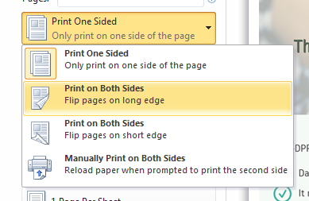
The leaflets have been created to help patients understand the new guidance, and as they are Word documents, they are adaptable and you can amend or add any further information , such as the ‘Contact Us’ details.

Further Information : QR Code
Patients can scan the QR code with their mobile phone app to find more information from the FPM website

Patient Leaflet – double-click the icon to open
Version A – A4 Leaflet | Version B – A5 Leaflet
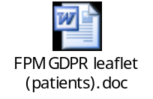 | 

