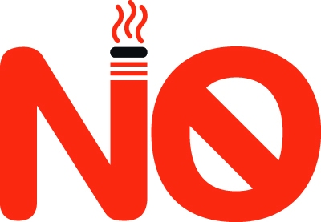

SMOKING
ANYWHERE ON THESE PREMISES
THIS INCLUDES
E CIGARETTES

PLEASE DO NOT STAND UNDER PORCH TO SMOKE – IF YOU NEED TO SMOKE PLEASE STAY OUTSIDE OF GATE.

