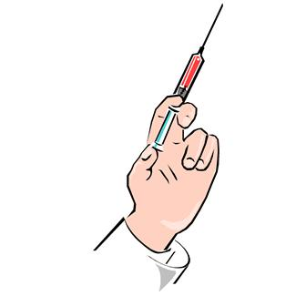
Vaccine and Health Advice for Patients
at Cleland Park Surgery

The following vaccines are available on an NHS prescription:

Diptheria Tetanus
Polio Typhoid
Hepatitis A

These cover most European countries including Turkey

The following vaccines/ tablets are not available on an NHS prescription and are issued on a private prescription:

Anti-malarial tablets Rabies
Hepatitis B Meningitis ACWY
Tick Borne Encephalitis Japanese Encephalitis
Yellow Fever (only available through specific Yellow Fever Centre)

Prescription and administration charges for these (NB Does not cover pharmacy charges):

Anti-Malarial Administration £10
Rabies £30 (covers all three visits)
Hepatitis B £30 (covers all three visits)
Meningitis ACWY £10
Tick Borne Encephalitis £30 (covers all three visits
Japanese Encephalitis £30 (covers all three visits)

Payment to be made to receptionist on collection
of prescription/s by CASH/CHEQUE only

